Image Sharpening Using Laplacian Mask
Experiment No: 22
Aim
To perform sharpening of an image using a Laplacian mask with a positive center coefficient in Python using OpenCV.
Laplacian Mask
The mask shown in your question is:
Here, the center coefficient is +5, and the four direct neighboring pixels have a coefficient of −1.
Tools Required
- Python 3.x
- OpenCV (cv2)
- NumPy
- VS Code / PyCharm / Jupyter Notebook
- Input image (image.jpg)
Procedure
- Install OpenCV and NumPy:
Bash
pip install opencv-python numpy
- Read the input image using OpenCV.
- Convert the image to grayscale.
- Define the Laplacian sharpening mask with a positive center coefficient.
- Apply the mask using cv2.filter2D().
- Display the original and sharpened images.
- Observe the enhancement of edges and fine details.
Code
import cv2
import numpy as np

# Read the image
image = cv2.imread("image.jpg")

# Check if image is loaded
if image is None:
print("Error: Image not found!")
exit()

# Convert image to grayscale
gray = cv2.cvtColor(image, cv2.COLOR_BGR2GRAY)

# Laplacian sharpening mask with positive center coefficient
mask = np.array([
[0, -1, 0],
[-1, 5, -1],
[0, -1, 0]
], dtype=np.float32)

# Apply the sharpening mask
sharpened = cv2.filter2D(gray, -1, mask)

# Display original image
cv2.imshow("Original Image", gray)

# Display sharpened image
cv2.imshow("Sharpened Image", sharpened)

# Wait for a key
cv2.waitKey(0)

# Close all windows
cv2.destroyAllWindows()
Output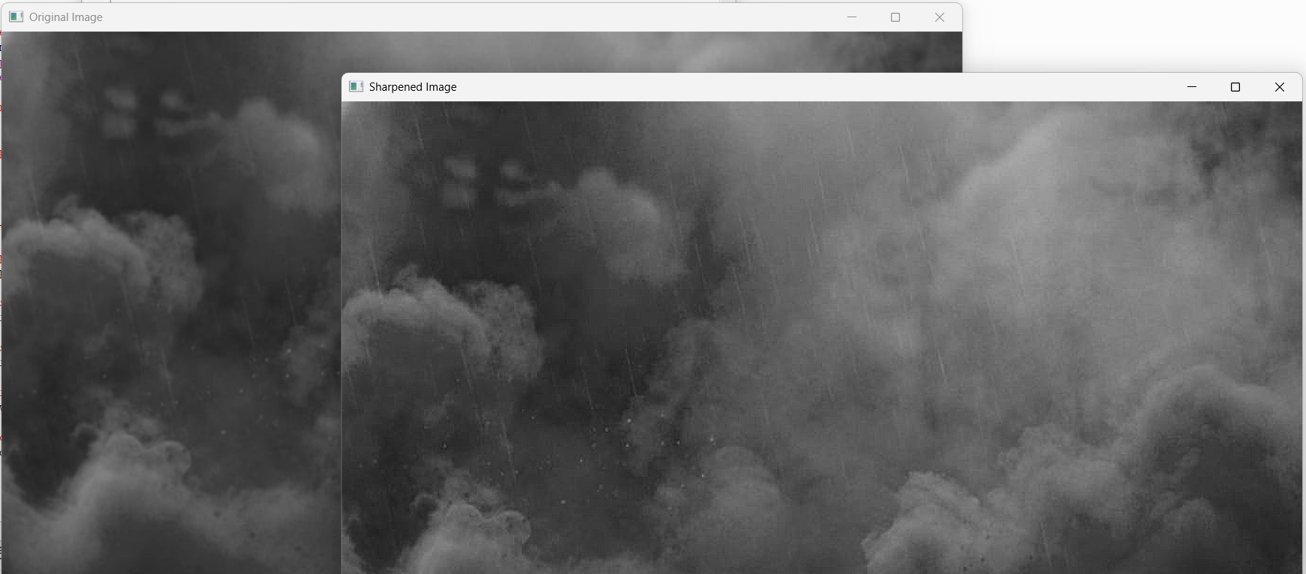
Result
The image was successfully sharpened using the Laplacian mask with a positive center coefficient. The mask

